Iris Species Classification - Beginner Project Notes

Project Objective
Build a machine learning model that predicts the species of an Iris flower using four measurements: sepal length, sepal width, petal length and petal width.

Step 1 - Load Dataset
What we did:
Imported pandas and sklearn, loaded the built-in Iris dataset, converted it into a DataFrame, added readable species names and previewed the first 5 rows.

Step 2 - Understand the Dataset
What we did:
Checked shape, columns, data types, missing values, statistics and class distribution. Found 150 rows, 5 columns, no missing values and 50 samples for each species.

Step 3 - Exploratory Data Analysis
What we did:
Used histograms, scatter plot and box plot to understand distributions, relationships and outliers.

Step 4 - Data Preprocessing
What we did:
Separated features (X) and target (y), then split into training (120 samples) and testing (30 samples).

Step 5 - Model Training
What we did:
Trained a DecisionTreeClassifier using the training data.

Step 6 - Evaluation
What we did:
Predicted on test data. Accuracy = 1.0 (100%). Confusion matrix showed all predictions correct. Classification report showed precision, recall and F1-score of 1.00.

Step 7 - Prediction
What we did:
Predicted a new flower [5.1,3.5,1.4,0.2] as Setosa.

EDA Outputs
Histogram Output
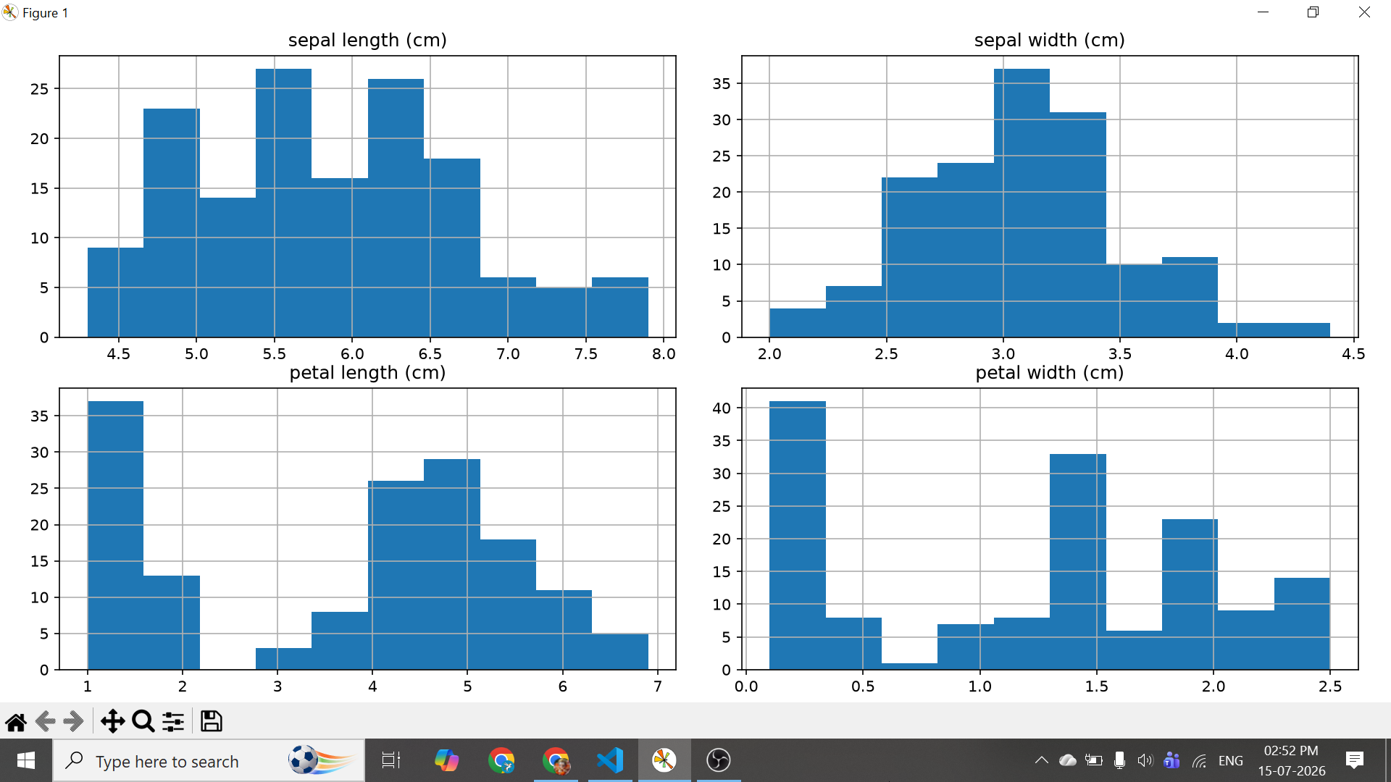
Scatter Plot Output
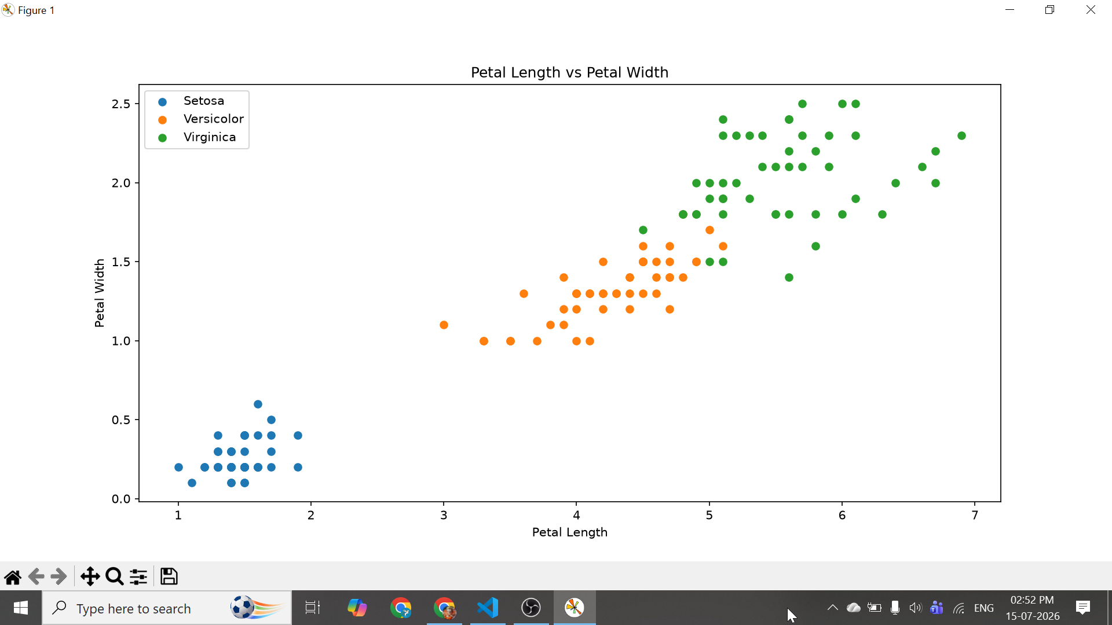
Box Plot Output
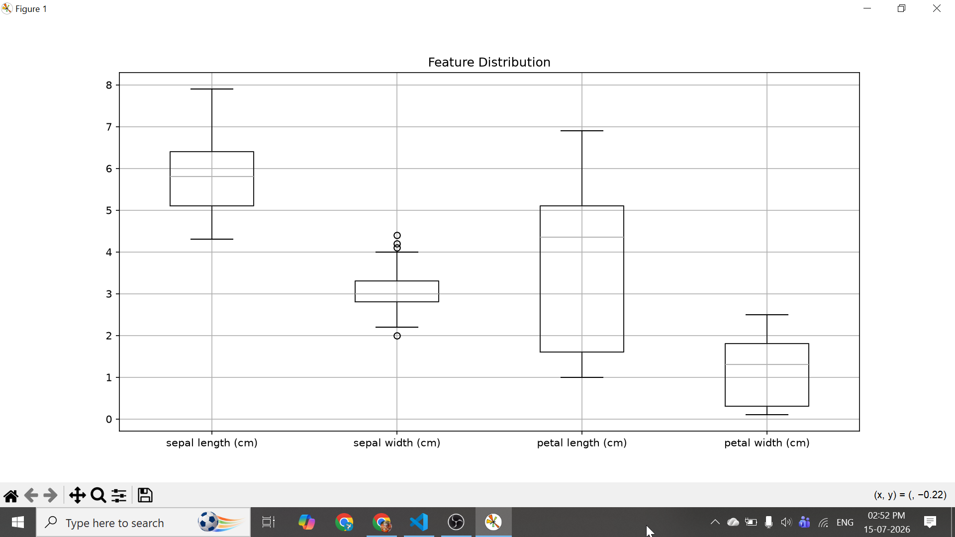

Your Final Results
Dataset: 150 rows, 5 columns
Missing Values: 0
Training Samples: 120
Testing Samples: 30
Accuracy: 100%
Predicted Example: Setosa

Important Terms & Simple Definitions
Dataset: Collection of data used for analysis or training.
DataFrame: Table-like structure in pandas.
Row: One observation (one flower).
Column: One property/feature.
Feature: Input variable used for prediction.
Target: Output we want to predict.
Classification: Predicting categories instead of numbers.
Pandas: Library for handling tabular data.
Scikit-Learn: Machine learning library.
EDA: Exploring data using statistics and graphs.
Histogram: Shows distribution of values.
Scatter Plot: Shows relationship between two features.
Box Plot: Shows spread, median and outliers.
Outlier: Value much different from others.
Preprocessing: Preparing data before training.
X: Input features.
y: Target labels.
Train-Test Split: Divides data into training and testing sets.
Training Data: Data used to teach the model.
Testing Data: Unseen data used to evaluate the model.
Decision Tree: Flowchart-like ML algorithm that learns decision rules.
fit(): Trains the model.
predict(): Predicts outputs for new data.
Model: Learned mathematical representation used for prediction.
Accuracy: Percentage of correct predictions.
Confusion Matrix: Table comparing actual vs predicted classes.
Precision: Of predicted positives, how many were correct.
Recall: Of actual positives, how many were found.
F1-Score: Balance between precision and recall.
Support: Number of actual samples in each class.
Random State: Makes results reproducible.
Missing Values: Empty values in dataset.
Mean: Average.
Median: Middle value.
Standard Deviation: Spread of data.

